# Api document

This document is about the guide to using the services related to the **BOOKSTORE** project.

The protocol used in these services will be **HTTP** and **RESTFUL** structured according to **JSON** standards.

The response consists of two parts HEADER and Body.

Header

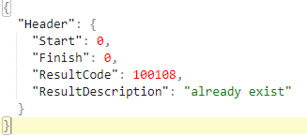

Body

The array of books or nil

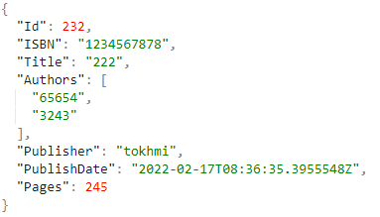

## Address

The primary address for accessing the services is as follows.

Localhost:8080/api/v1/book

Change IP, PORT services will be based on the following guide.

Main.go 🡪 ADDR (change localhost:8080 to another IP and PORT)

## Services

Allbooks

/range

Request

"http://localhost:8080/api/v1/book/books/0-10

Response body considered of list of book with paging

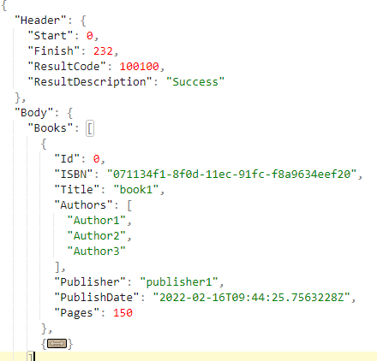

-----------------------------------------------------------------------------------------------------------------------

Book: find especial book according to ISBN

/findbook

Request

"http://localhost:8080/api/v1/book/books/EU-123879

Response

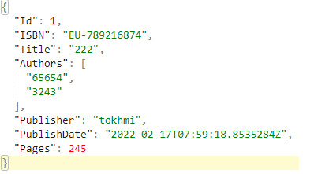

ADD: add a book to store

/add

Request

"http://localhost:8080/api/v1/book/books/add



Response

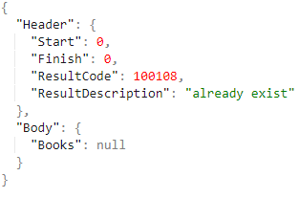

------------------------------------------------------------------------------------------------------------------------------

Delete: delete especial book according to ISBN

/delete

Request

"http://localhost:8080/api/v1/book/books/EU-123879

Response

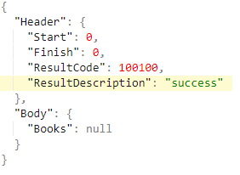

Update: update especial book according to ISBN

/delete

Request

http://localhost:8080/api/v1/book/books/update



Response



Map result

|  |  |
| --- | --- |
| **Result code** | **description** |
| 100100 | success |
| 100101 | Bad request |
| 100102 | Min value check |
| 100103 | Max value check |
| 100104 | overflow |
| 100105 | Bad request |
| 100106 | Not found |
| 100107 | Check inputs |
| 100108 | Internal error |
| 100109 |  |
| 100110 | Book added |